**Project-4**

**ONLINE GROCERY STORE**

**Gundrala Bharath Kumar**

**Github::**

**ER Diagram::**

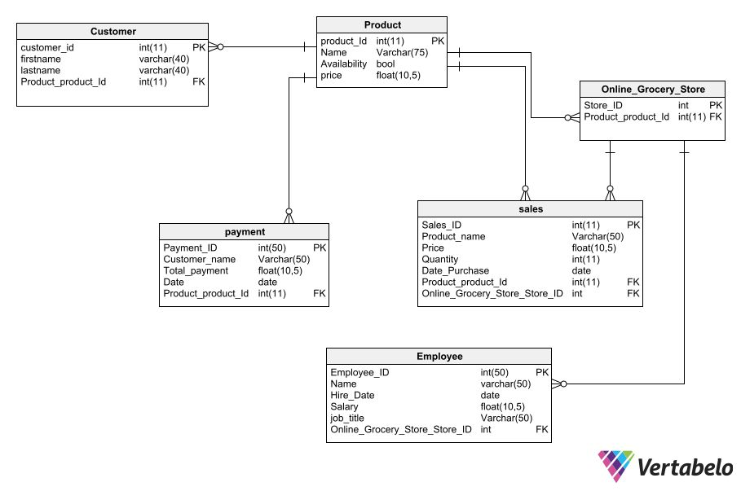

**Data Definition Languages and Data**

**Manipulation Languages:**

**Show tables and Describe tables:**

It is used to show all tables in the Database.

Syntax: Show tables;

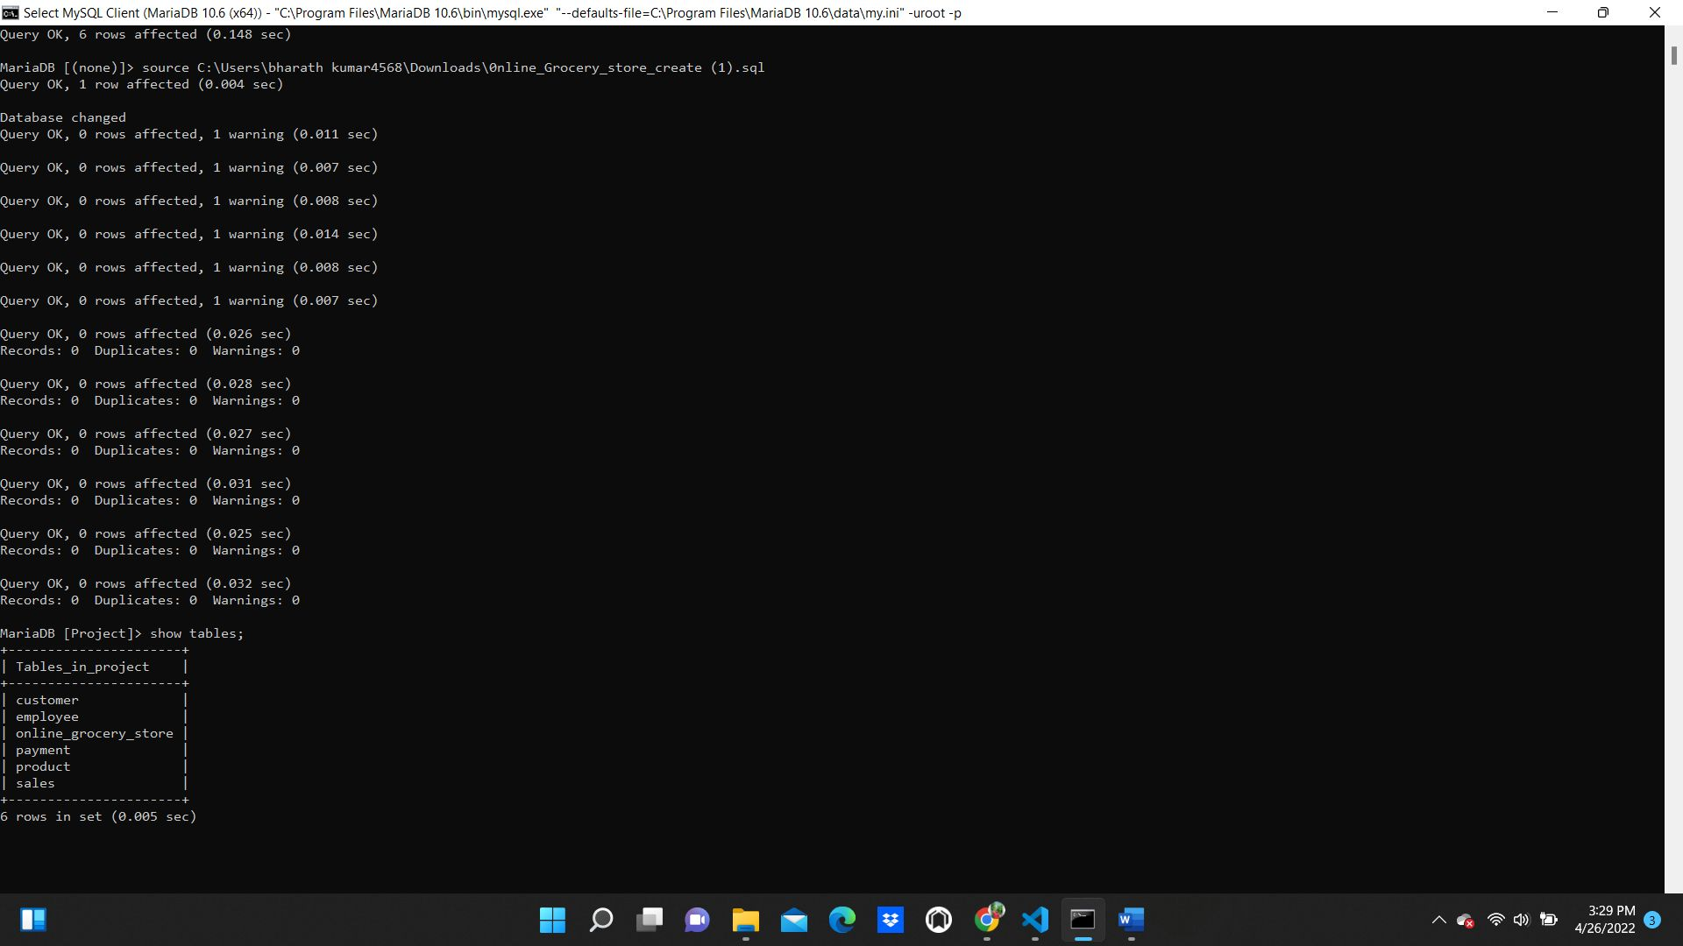

In the below screenshots I have used describe,insert and select queries for all tables and used delete query for payment table.

Describe query: Describe query describes the table with the columns it has.

• Syntax : describe table name;

• Example : describe customer;

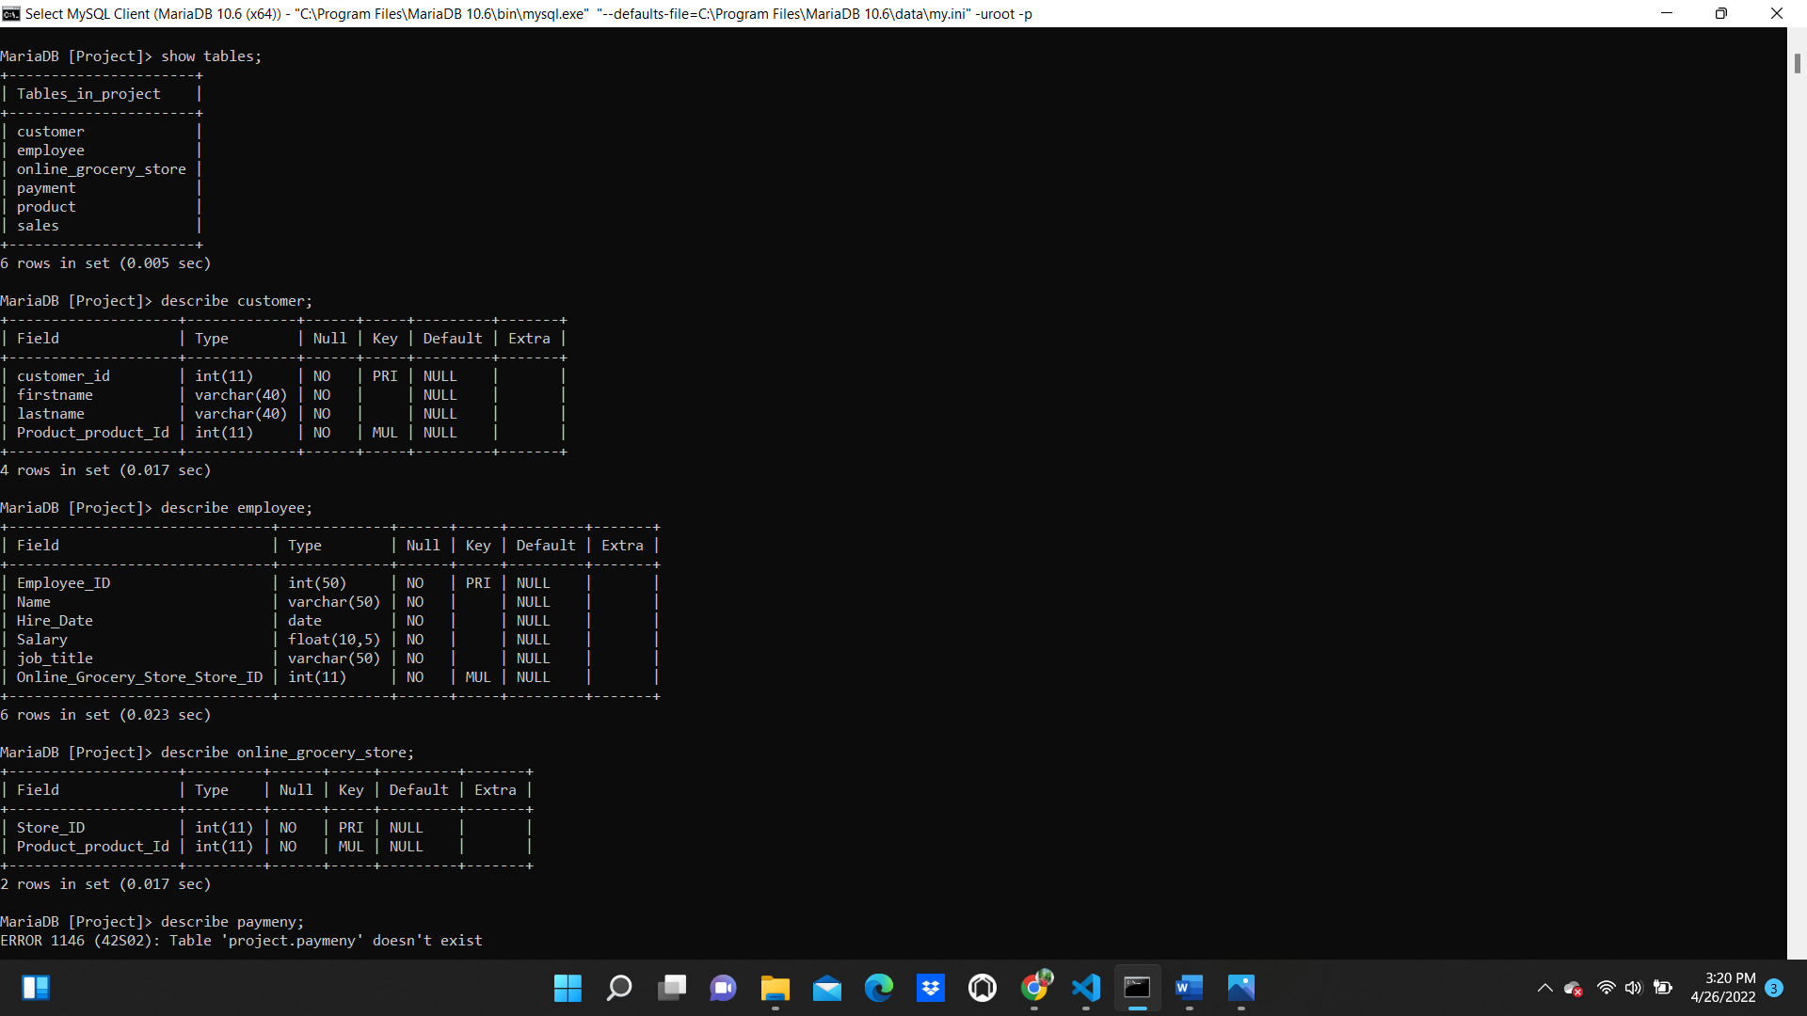

**Two insert statements:**

Insert query : It is used to insert the values into the table. Here, I have inserted at least 3 values for one entity or table.

• Syntax : Insert into table name values(Column1 Value'...):

• Example: Insert into product values (101, 'butter’ ,0,8.00);

• In the below example we added values to the product,customer table

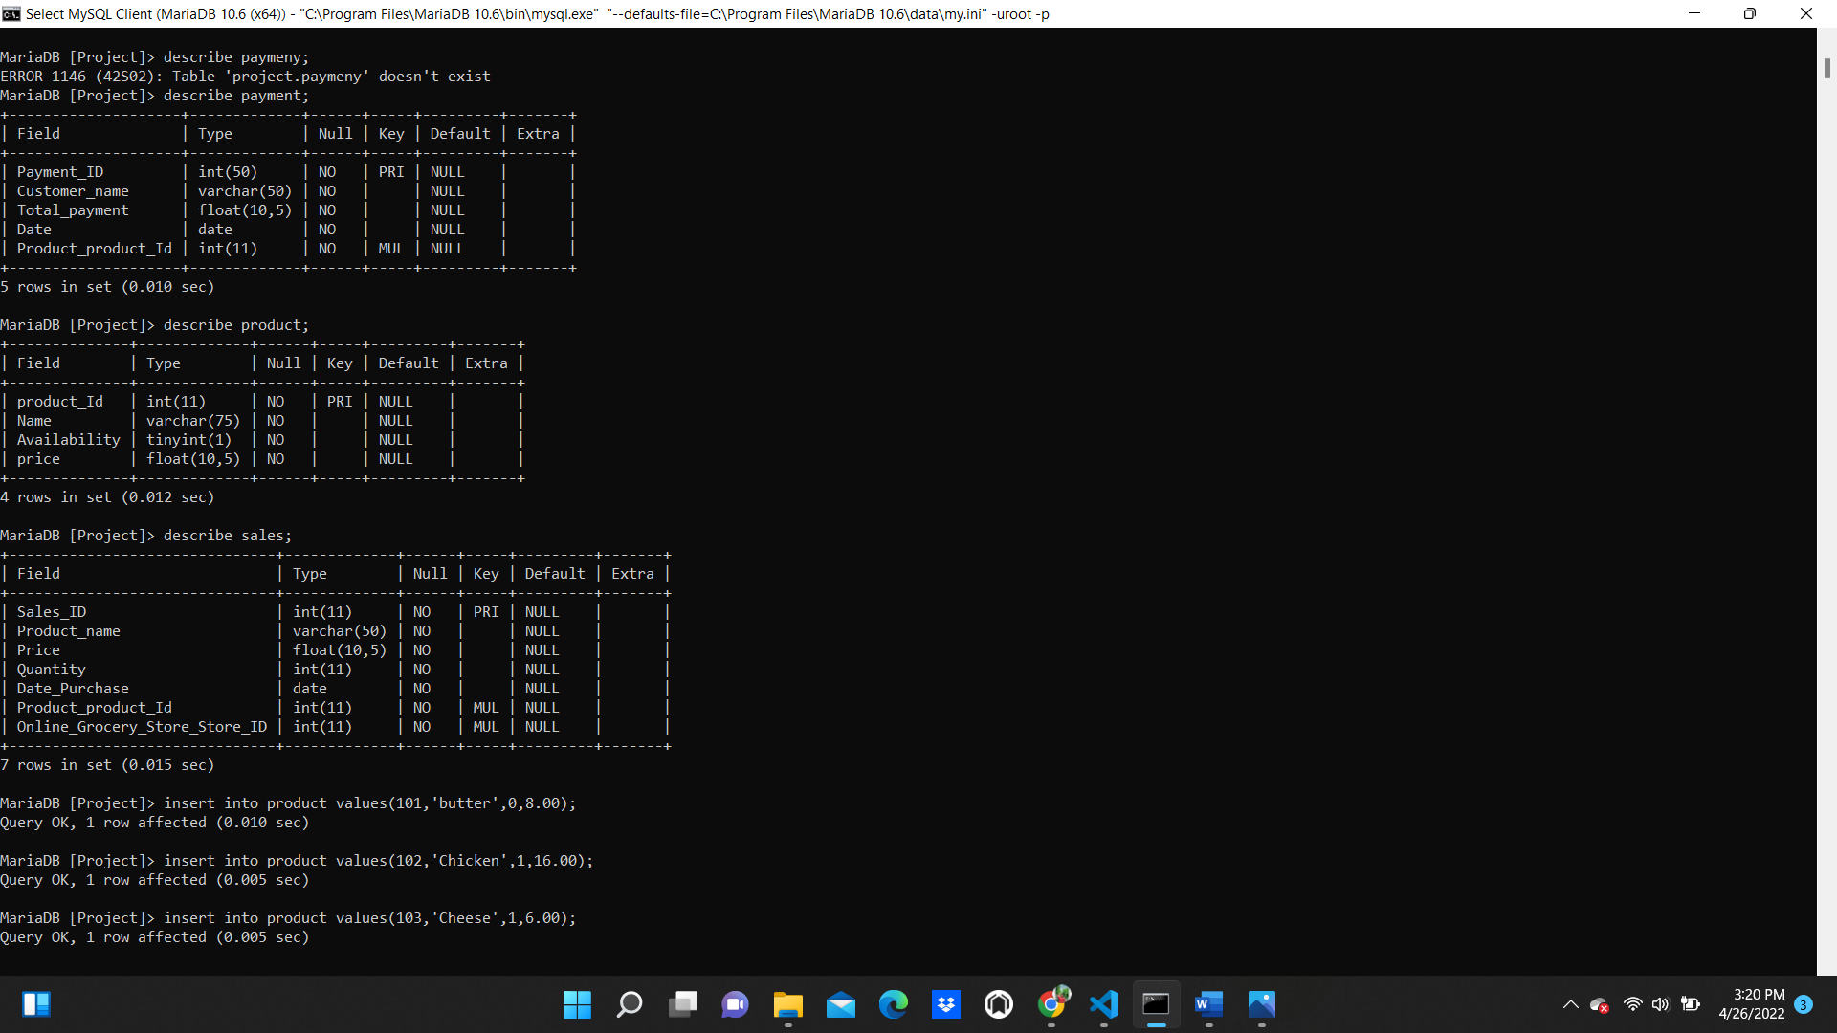

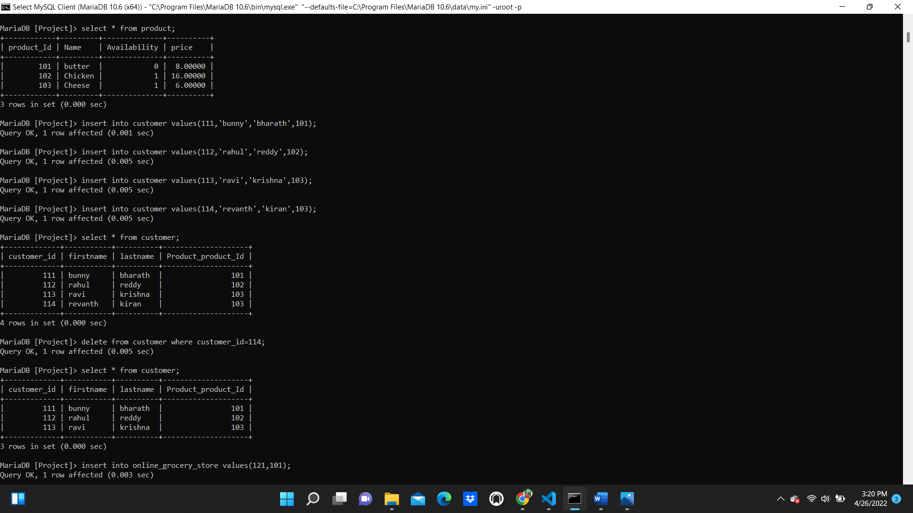

**Update statement:**

Update query is used to update the table entities .

Syntax: update table_name set Column_name=new_value where condition;

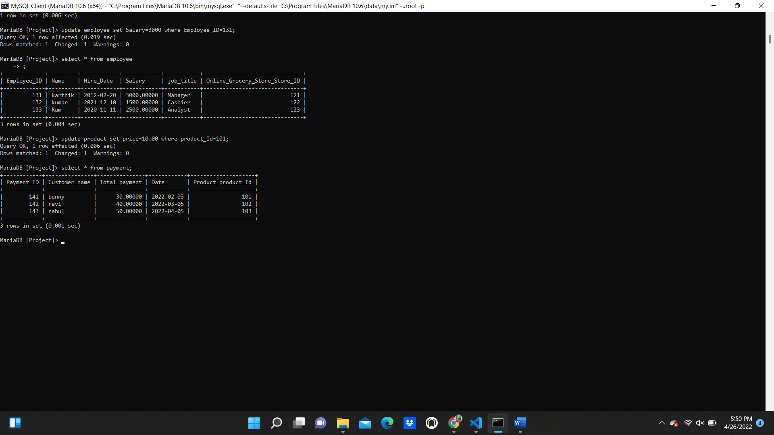

**Select statements:**

Select query: Select query is used to select the values from the table. Here

I used * which is to show all the records (rows) in the tables.

• Syntax: select * from table name;

• Example: Select * from customer;

• In the below example it results in all the records from the customer table.



**Delete statement:**

Delete query: It is used to delete the records from the table.

Syntax: delete from table_name where condition;

Below is the example for delete statement in customer table.



**Joins and multi table queries:**

Join statements is used to join two or more tables.

There are 3 types of joins such as Inner Join,Left Join, Right Join.

In the below example I have used inner joins example

